CONSTRUCTION SHOP MANAGEMENT
SYSTEM
UNDERGRADUATE PROJECT
A Project submitted to the Department of Computer Science and Engineering in fulfillment of the requirements for the degree of
B.Sc. Eng. in CSE

By
GROUP: Black Bard
UNDER SUPERVISION OF:

Dipu Akter Shila
Teaching assistant,
Dept. of CSE
Bangladesh University of Business and Technology


Bangladesh University of Business & Technology
(BUBT)

Department of Computer Science and Engineering

CONSTRUCTION SHOP MANAGEMENT SYSTEM

NO | NAME | ID
1. | MD. MEHRAZ HOSEN | 19202103122
2. | SMARANIKA SARKER | 19202103138
3. | JOINAB BINTE JANNAT | 19202103139

Bangladesh University of Business & Technology
(BUBT)

Department of Computer Science and Engineering

Declaration of Authorship

We, Md. Mehraz Hosen, Smaranika Sarker _{and} Joinab Binte Jannat declare that this project titled, “CONSTRUCTION SHOP MANAGEMENT SYSTEM” and the work presented in it are our own. We confirm that:

____________________
Md. Mehraz Hosen
ID: 19202103122
Date:

____________________
Smaranika Sarker
ID: 19202103138
Date:

____________________
Joinab Binte Jannat
ID: 19202103139
Date:

Certificate

This is to certify that the project entitled, "CONSTRUCTION SHOP MANAGEMENT SYSTEM" and submitted by Md. Mehraz Hosen, Smaranika Sarker and Joinab Binte Jannat ID No. 19202103122, 19202103138, 19202103139 in fulfillment of the requirements of embodies the work done by them under my supervision.

______________________________
Dipu Akter Shila
Teaching assistant,
Dept. of CSE
Bangladesh University of Business and Technology

Dedication

Dedicated to our parents for all their love and inspiration.

Abstract

The “CONSTRUCTION SHOP MANAGEMENT SYSTEM” is designed & developed for a shop to manage their records of available stocks and sell them to the customers. This system makes the work of the shopkeepers easy as it keeps all the records of the materials and also collects feedback from the customers. This system first checks the availability of the products and their quantity then enter the record into the record table after deducting a number of the products from the quantity but isn't saves the record for future use if needed. In this project we can easily maintain systems sales details. We can see the Systems details before selling the particular products.

Acknowledgements

First of all, we are thankful and expressing our gratefulness to Almighty Allah who offers us his divine blessing, patient, mental and physical strength to complete this project work.

We would like to convey from our heart full thanks to our project supervisor: Dipu Akter Shila, Department of Computer Science and Engineering (CSE), Bangladesh University of Business and Technology (BUBT). Who always gave valuable suggestions & guidance for the completion of our project. She helped us to understand & remember important details of the project. Our project has been a success because of her guidance. And finally, we thank the members of our section for their support & encouragement.

Approval

This project "CONSTRUCTION SHOP MANAGEMENT SYSTEM" Submitted by Md. Mehraz Hosen, Smaranika Sarker and Joinab Binte Jannat ID No. 19202103122, 19202103138 and 19202103139 Department of Computer Science and Engineering (CSE), Bangladesh University of Business and Technology (BUBT) under the supervision of Dipu Akter Shila; Lecturer, Department of Computer Science and Engineering has been accepted as satisfactory for the fulfillment of the requirement for the degree of Bachelor of Science (B.Sc. Eng.) in Computer Science and Engineering and approved as to its style and contents.

______________________________
Supervisor:
Dipu Akter Shila
Teaching assistant,
Dept. of CSE
Bangladesh University of Business and Technology (BUBT)

______________________________
Chairman:

Dr.Muhammad Firoz Mridha
Associate Professor and Chairman
Department of CSE
Bangladesh University of Business and Technology (BUBT)

Contents
Declaration of Authorship 3
Certificate 4
Dedication 5
Abstract 6
Acknowledgements 7
Approval 8
Contents 9

- Introduction
1.1 Introduction 10
1.2 Objectives 10
1.3 Purpose 11
2. System Analysis
2.1 User Requirements 12
2.2 Proposed System 14
2.3 Software Tools Used 1
3. System Design
3.1 Diagram 15
4. Code Analysis
4.1 Code 16
5. System Implementation
5.1 Module Description 29
5.2 System Output 30
Conclusion 34
Future Enhancement 34

Introduction

1.1 Introduction
The “Construction shop management system” is a project which assists in keeping the Record of whatever seller have in the stock, also it keeps track of the remaining product balance which due after selling the product. Construction shop management System is a C++ Project for store management. Sell construction materials and accessories. Construction Shop Management System is a window-based software designed for use in stores.

This application is reduced as much as possible to avoid errors while entering the data. It also provides an error message while entering invalid data. No formal knowledge is needed for the user to use this system. Thus by this all, it proves it is user-friendly. Construction Material shop Management System as described above can lead to error-free and fast management system. It can assist the user to concentrate on their other activities rather to concentrate on the Record Keeping does it will help Organization in better utilization of resources.

1.2 Objectives
The objective of our project to provides management facility to construction shop. We have given many facilities for users in this project.
1) Seller
2) Employee
3) Customer
4) Brand Dealership
5) Feedback
6) Exit

1.3 Purpose
This is the project about the construction shop management System. It automates the Systems records, their Selling and Maintenance, Balance evaluation, due to the calculation of other functions. In other words, you can say it a complete construction shop management System. In this project, we can easily maintain systems sales details. We can see the Systems details before selling the particular items & view our requirements.
System Analysis

2.1. User Requirement

    - User Story

      - As a < Seller >, I want < to Check available Products > so that < I can Check it > Acceptance criteria < seller will be able to Check available Products >

      - As a < Seller >, I want < to add update products > so that < I can add new products > Acceptance criteria < seller will be able to update products >

      - As a < Seller >, I want < to update see total transactions> Acceptance criteria < seller will be able to check total transactions >

      - As a < Seller >, I want < to Exit> Acceptance criteria < seller will be able to Exit the site >

      - As a < Employee >, I want < to Check available Products > so that < I can Check it > Acceptance criteria < employee will be able to Check available Products >

      - As a < Employee >, I want < to add update products > so that < I can add new products > Acceptance criteria < employee will be able to update products >

      - As a < Employee >, I want < to update see total transactions> Acceptance criteria < employee will be able to check total transactions >

      - As a < Employee >, I want < to Exit> Acceptance criteria < employee will be able to Exit the site >

      - As a < Customer >, I want < to Check Products > so that < I can Check them > Acceptance criteria < Customer will be able to see the Products >

      - As a < Customer >, I want < to Purchase some Products > so that < I can Buy them > Acceptance criteria < Customer will be able to buy any Available Product >

      - As a < Customer >, I want < to Exit> Acceptance criteria < Customer will be able to Exit the site >

      - As a < visitor >, I want < see Brand Dealership > so that < I can see Brand Dealership > Acceptance criteria < anyone can able to see Brand Dealership >

      - As a < Visitor >, I want < Have the feedback> so that < I can see share my thoughts > Acceptance criteria < anyone can able to share their Ideas >

2.2 Proposed System
- It is automated computerized web based software system.
- It uses latest technologies like C++.
- It is super easy to operate.
- Attractive user interface.

2.3 Software Tools Used
We used “Code::blocks (20.03)” software to complete this project. It’s a largely popular software for solving C or C++ programming problems. We only use this software for completion of our project.

System Design

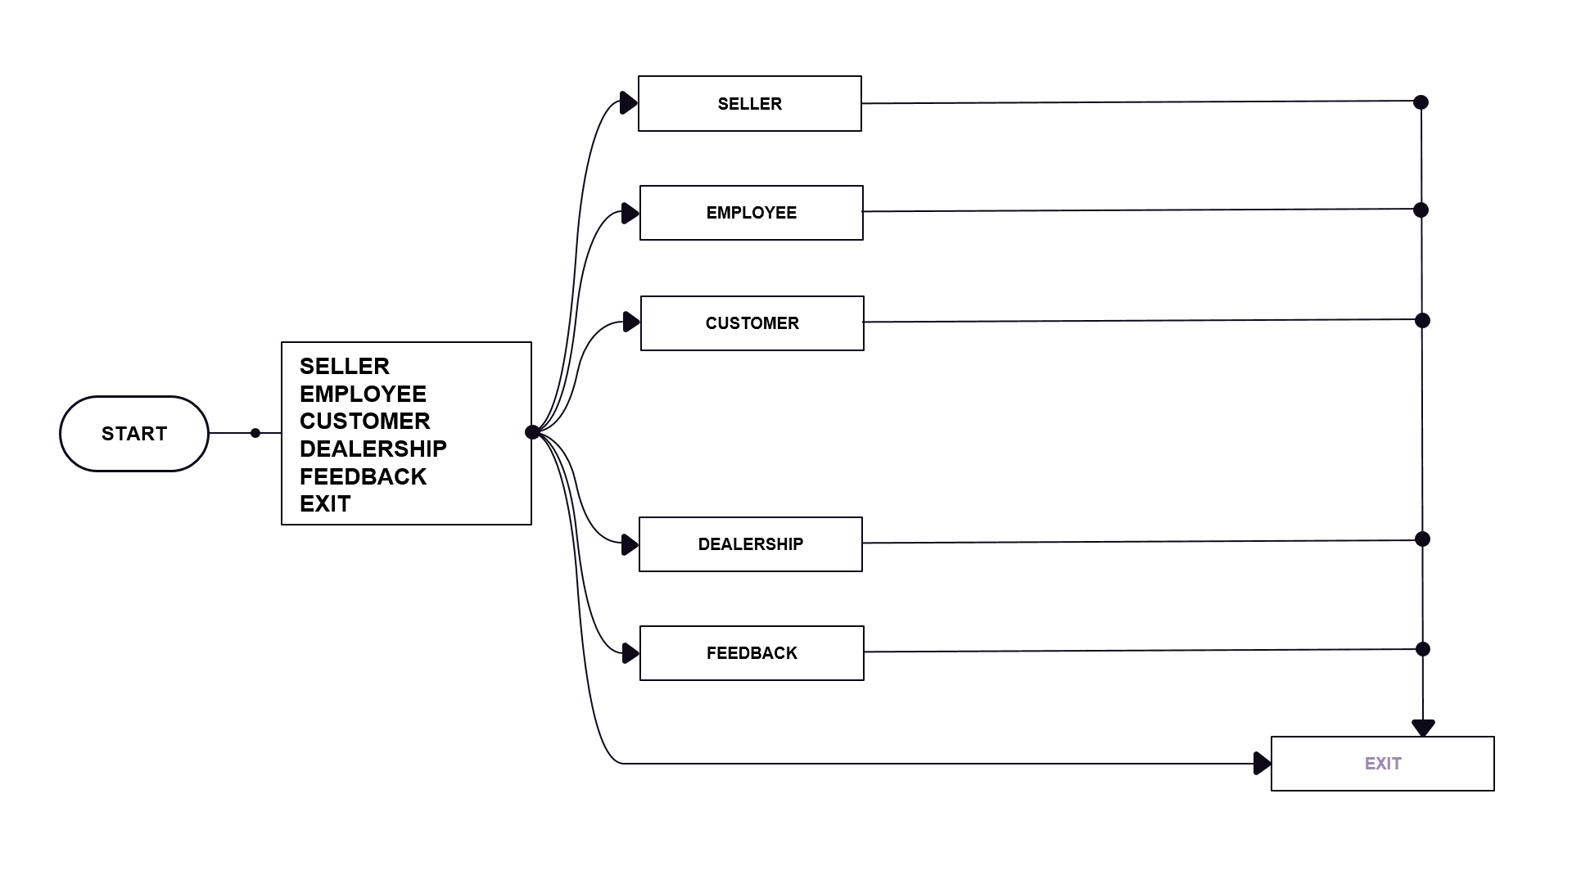
3.1 Diagram

Code Analysis
4.1 Code

#include <windows.h>
#include <iostream>
#include <fstream>
#include <stdlib.h>
using namespace std;

//Failed and successful trans
int failure=0;
int success=0;
void Trans(int a)
{
if(a==0)
failure++;
else
success++;
}
class Product
{
//PRIVATE SECTION FOR SELLER (PART 001)
private:
int SKU;
string product; //product name
string brand; //Brand name
double price; //Selling Price
double stock;//available stock unit counter

//PRODUCT DETAILS UPDATE PART
void priceUpdate()
{
cout<<"\n\t\t\t\t\t\tEnter the new price: ";
cin>>price;
cout<<endl;
system("CLS");
}
void stockUpdate()
{
cout<<"\n\t\t\t\t\t\tEnter the new stock: ";
cin>>stock;
cout<<endl;
system("CLS");
}

// CONSTRUCTOR AKA MAIN CONSTRUCTOR SITE (PART 002)
public:
Product(int u,string x,string y, long double w, double v) //Class_name Objects (Parameters)
{
SKU=u;
product=x;
brand=y;
price=w;
stock=v;
}
Product(string x,string y) //constructor
{
product=x;
brand=y;
}
int search(Product x) //searching the Product in the list
{
if(product==x.product&&brand==x.brand)
return 1;
else
return 0;
}
void No_Of_Products() //checking no. of copies and calculating the total price
{
int n;
cout<<"\n\t\t\t\t\t\tProducts Details: "<<endl;
Productdetails();
cout<<"\t\t\t\t\t\tEnter required number of Products: ";
cin>>n;
if(n>stock)
{
cout<<"\t\t\t\t\t\tRequired amount is not in stock"<<endl;
Trans(0);
}
else
{
cout<<"\n\n\t\t\t\t\t\tTotal cost of the items: "<<n*price<<endl;
stock=stock-n;
cout<<"\n\t\t\t\t\t\tRemaining stock: "<<stock<<endl;
Trans(1);
}
}
//CHECK AVAILABLE PRODUCTS
void Productdetails()
{
cout<<"\t\t\t\t\t\tProduct SKU: "<<SKU<<endl;
cout<<"\t\t\t\t\t\tproduct: "<<product<<endl;
cout<<"\t\t\t\t\t\tBrand: "<<brand<<endl;
cout<<"\t\t\t\t\t\tPrice: "<<price<<" Taka"<<endl;
cout<<"\t\t\t\t\t\tThe stocks available: "<<stock<<endl;
cout<<endl;
}
void update() //update price and stock
{
int x;
cout<<"\t\t\t\t\t\tSelect what to update\n\t\t\t\t\t\t1. Price\n\t\t\t\t\t\t2. Stock\n\t\t\t\t\t\t3. Go Back"<<endl;
cin>>x;
cin.ignore();
cin.clear();
system("CLS");
if(x==1)
priceUpdate();
else if(x==2)
stockUpdate();
else
return;
cin.ignore();
cin.clear();
system("CLS");
}
};
//Add Some object (I mean add some Product & Their Details) (PART 003)
//After finishing that we'll go "int main()" Function

Product p1(122,"Steel","BSRM",63000,26000); //Sku number: 122, Product:Steel, Brand:BSRM, Price: 63K(Per Ton), Stock available: 26ton
Product p2(222,"Cement","Holcim",450,1450); //Sku number: 222, Product: Cement, Brand: Holcim, Price: 450Tk(Per bag), Stock available: 1450 bag
Product p3(322,"Sand","Moynamoti",2800,2000); //Sku number: 322, Product: Sand, Brand: Moynamoti, Price: 63K(Per 100 feet), Stock available: 2k feet
Product p4(422,"Bricks","Shapla Bricks",8900,25000); //Sku number: 142, Product:Bricks, Brand: Shapla Bricks Price: 1000 Pics Stock available: 25k Pcs

void seller()
{
int a,n;
while(1){
cout<<"\n\t\t\t\t\t\tWELCOME TO MUNNITRAD \n\n\t\t\t\t\t\t1. Products List \n\t\t\t\t\t\t2. Update\n\t\t\t\t\t\t3. Transaction\n\t\t\t\t\t\t4. Main Menu"<<endl;
cin>>a;
cout<<endl;
system("CLS");
switch(a)
{
case 1: cout<<"\n\n\t\t\t\t\t\tWELCOME TO MUNNITRAD\n\n\t\t\t\t\t\tProduct Details:\n\t\t\t\t\t\t_________________________ "<<endl;
p1.Productdetails();
cout<<"\n\t\t\t\t\t\t_________________________"<<endl;
p2.Productdetails();
cout<<"\n\t\t\t\t\t\t_________________________"<<endl;
p3.Productdetails();
cout<<"\n\t\t\t\t\t\t_________________________"<<endl;
p4.Productdetails();
cout<<"\n\t\t\t\t\t\t_________________________\n\n"<<endl;
break;
cin.ignore();
cin.clear();
system("CLS");

case 2: cout<<"\n\t\t\t\t\t\tProduct Update\n"<<endl;
cout<<"\t\t\t\t\t\tAvailable Product: \n\t\t\t\t\t\t1. Products: 122, Steel , BSRM\n\t\t\t\t\t\t2. Products: 222, Cement , Holcim\n\t\t\t\t\t\t3. Products: 322, Sand , Moynamoti\n\t\t\t\t\t\t4. Products: 422, Bricks, Shapla Bricks\n\nEnter the Product SKU for update: ";
cin>>n;
cin.ignore();
cin.clear();
system("CLS");
if(n==122)
p1.update();
else if(n==222)
p2.update();
else if(n==322)
p3.update();
else if(n==422)
p4.update();
else
cout<<"\t\t\t\t\t\t******\n\t\t\t\t\t\tInvalid\n\t\t\t\t\t\t*****"<<endl;
break;
cout<<"\t\t\t\t\t\tAvailable Product: \n\t\t\t\t\t\t1. Products: 122, Steel , BSRM\n\t\t\t\t\t\t2. Products: 222, Cement , Holcim\n\t\t\t\t\t\t3. Products: 322, Sand , Moynamoti\n\t\t\t\t\t\t4. Products: 422, Bricks, Shapla Bricks\n\nEnter the Product SKU for update: ";
cin>>n;
cin.ignore();
cin.clear();
system("CLS");

case 3: cout<<"\n\n\t\t\t\t\t\tTotal failed transaction: "<<failure<<endl;
cout<<"\t\t\t\t\t\tTotal successful transaction: "<<success<<endl;
cout<<endl;
break;
cin.ignore();
cin.clear();
system("CLS");

case 4:
return;
}
}
}
//Employee options
void Employee()
{
int a,n;
while(1){
cout<<"\n\t\t\t\t\t\tWELCOME TO MUNNITRAD \n\n\t\t\t\t\t\t1. Products List \n\t\t\t\t\t\t2. Update\n\t\t\t\t\t\t3. Transaction\n\t\t\t\t\t\t4. Main Menu"<<endl;
cin>>a;
cout<<endl;
system("CLS");
switch(a)
{
case 1: cout<<"\n\t\t\t\t\t\tProduct Details:\n\t\t\t\t\t\t_________________________ "<<endl;
p1.Productdetails();
cout<<"\n\t\t\t\t\t\t_________________________"<<endl;
p2.Productdetails();
cout<<"\n\t\t\t\t\t\t_________________________"<<endl;
p3.Productdetails();
cout<<"\n\t\t\t\t\t\t_________________________"<<endl;
p4.Productdetails();
cout<<"\n\t\t\t\t\t\t_________________________\n\n"<<endl;
break;
cin.ignore();
cin.clear();
system("CLS");

case 2: cout<<"\n\t\t\t\t\t\tProduct Update\n"<<endl;
cout<<"\t\t\t\t\t\tAvailable Product: \n\t\t\t\t\t\t1. Products: 122, Steel , BSRM\n\t\t\t\t\t\t2. Products: 222, Cement , Holcim\n\t\t\t\t\t\t3. Products: 322, Sand , Moynamoti\n\t\t\t\t\t\t4. Products: 422, Bricks, Shapla Bricks\n\nEnter the Product SKU for update: ";
cin>>n;
cin.ignore();
cin.clear();
system("CLS");
if(n==122)
p1.update();
else if(n==222)
p2.update();
else if(n==322)
p3.update();
else if(n==422)
p4.update();
else
cout<<"\t\t\t\t\t\t******\n\t\t\t\t\t\tInvalid\n\t\t\t\t\t\t*****"<<endl;
break;
cout<<"\t\t\t\t\t\tAvailable Product: \n\t\t\t\t\t\t1. Products: 122, Steel , BSRM\n\t\t\t\t\t\t2. Products: 222, Cement , Holcim\n\t\t\t\t\t\t3. Products: 322, Sand , Moynamoti\n\t\t\t\t\t\t4. Products: 422, Bricks, Shapla Bricks\n\nEnter the Product SKU for update: ";
cin>>n;
cin.ignore();
cin.clear();
system("CLS");

case 3: cout<<"\n\n\t\t\t\t\t\tTotal failed transaction: "<<failure<<endl;
cout<<"\n\n\t\t\t\t\t\tTotal successful transaction: "<<success<<endl;
cout<<endl;
break;
cin.ignore();
cin.clear();
system("CLS");

case 4:
return;
}
}
}

//customer options
void customer()
{
int x;
while(1)
{
cout<<"\n\n\t\t\t\t\t WELCOME TO MUNNITRAD\n\n\t\t\t\t\t\tEnter a option \n\t\t\t\t\t\t1.Show all Products\n\t\t\t\t\t\t2.Purchase Products\n\t\t\t\t\t\t3. Main Menu"<<endl;
cin>>x;
system("CLS");
if(x==1)
{
cout<<"\n\t\t\t\t\t\t______________________\n\t\t\t\t\t\tProduct Details: \n\t\t\t\t\t\t______________________"<<endl;
p1.Productdetails();
p2.Productdetails();
p3.Productdetails();
p4.Productdetails();
}

else if(x==2)
{
string a;
string b;
cout<<"\t\t\t\t\t\tAvailable Product: \n\t\t\t\t\t\t1. Products: 122, Steel , BSRM\n\t\t\t\t\t\t2. Products: 222, Cement , Holcim\n\t\t\t\t\t\t3. Products: 322, Sand , Moynamoti\n\t\t\t\t\t\t4. Products: 422, Bricks, Shapla Bricks";
cout<<"\n\t\t\t\t\t\tEnter product name: ";
cin>>a;
cout<<"\t\t\t\t\t\tEnter brand name: ";
cin>>b;
cin.ignore();
system("CLS");
Product p6(a,b);
if(p6.search(p1)==1)
p1.No_Of_Products();
else if(p6.search(p2)==1)
p2.No_Of_Products();
else if(p6.search(p3)==1)
p3.No_Of_Products();
else if(p6.search(p4)==1)
p4.No_Of_Products();
else
{
cout<<"\t\t\t\t\t\tThis Products are not available!"<<endl;
Trans(0);
}
}
else
return;
}
cin.clear();
}
void Dealers()
{
cout<<"\n\t\t\t\t\t\tWelcome To MunniTrad\n\n\t\t\t\t\t\tOur Valuable Brands dealership\n\t\t\t\t\t\t1. BSRM\n\t\t\t\t\t\t2. Holcim\n\t\t\t\t\t\t3. Moynamoti\n\t\t\t\t\t\t4. Shapla Bricks"<<endl;
}

//FEEDBACK OPEARATION
void feedback()
{
fstream FEEDBACK;
FEEDBACK.open("\t\t\t\t\t\tPeople's Feedback!",ios::out);
cout<<"\n\n\t\t\t\t\t\tHave the feedback? We'd love to hear it, But please don't share sensitive information!\n";
cin.ignore();

cout<<"\n\n\t\t\t\t\t\t01. Enter Name: ";
string Name;
getline(cin, Name);
cin.clear();
FEEDBACK<<Name<<endl;

cout<<"\t\t\t\t\t\t02. Enter Feedback: ";
string feedback;
getline(cin, feedback);
cin.clear();
FEEDBACK<<feedback<<endl;

cout<<"\t\t\t\t\t\t-------------------------------------Thank you so much for your valuable Feedback!-------------------------------------"<<endl;
FEEDBACK.close();
cin.ignore();
system("CLS");
}

int main()
{
//Here We'll made option based program for Seller, Feedback & Customer (PART 004)
SetConsoleTextAttribute(GetStdHandle(STD_OUTPUT_HANDLE), 14); //Color Change
int a;
while(1)
{
cout<<"\n\t\t\t\t\t\tWELCOME TO MUNNITRAD"<<endl;
cout<<"\n\t\t\t\t\t\tEnter your identity:\n\n\t\t\t\t\t\t1. Seller\n\t\t\t\t\t\t2. Employee\n\t\t\t\t\t\t3. Customer\n\t\t\t\t\t\t4. Brand Dealership\n\t\t\t\t\t\t5. Feedback\n\t\t\t\t\t\t0. Exit"<<endl;
cin>>a;
cout<<endl;
system("CLS");

if(a==1){
seller();
system("CLS");
}
else if(a==2){
Employee();
system("CLS");
}
else if(a==3){
customer();
system("CLS");
}
else if(a==4){
Dealers();
}
else if(a==5){
feedback();
}
else
return 0;
}
}

System Implementation

5.1 Module Description
This project is built with the concept of object-oriented programming. The below modules are implemented in the project:
- Object oriented: All the data are stored using objects. Meaning each object has the same variable but different data in them as object do not share the same memory.

- Encapsulation: Accessing the data are only possible through certain methods. No direct access is granted. Thus, it provides data security.

  - System Output

    - Main menu: It’s the first window of our output. After running our project first this window will come.

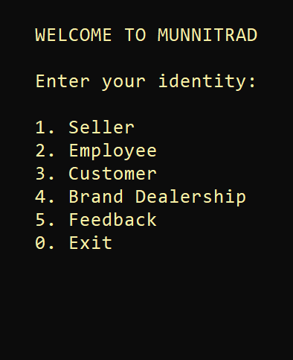

    - Seller: If we enter “1” as our choice then Seller window will appear. Where the Seller can work as per his requirement. The shopkeeper will be able to control everything in his shop from here.

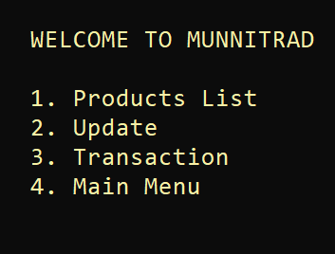

    - Employee: If we enter “2” as our choice then the employee window will appear. Employee option has been made exactly the same as seller option. Where the employee can work as per his requirement. The employee will be able to control some parts in his owner's shop from here.

    - Customer: If we enter “3” as our choice then customer window will appear. As a customer, in this module, you will be able to see all the available products and able to purchase from there as needed if you wish.

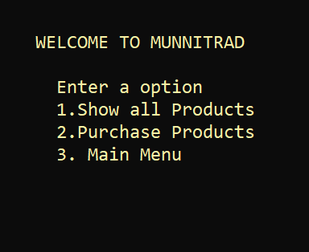

    - Brand Dealership: If we enter “4” as our choice then customer window will appear. The most important thing in any business is the Brand dealership. In this module, we can see all individual dealerships of MunniTrad.
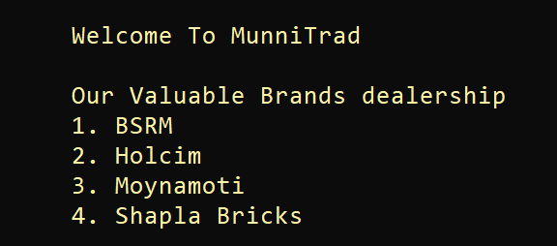
    - Feedback: If we enter “5” as our choice then feedback window will appear. One of the most important thing in any online or offline business is to get people's feedback. Feedback is very helpful. Feedback is valuable information that will be used to make important decisions. Top-performing companies are top-performing companies because they consistently search for ways to make their best even better. And with the help of feedback, they can work on their mistakes and update their app/Project.
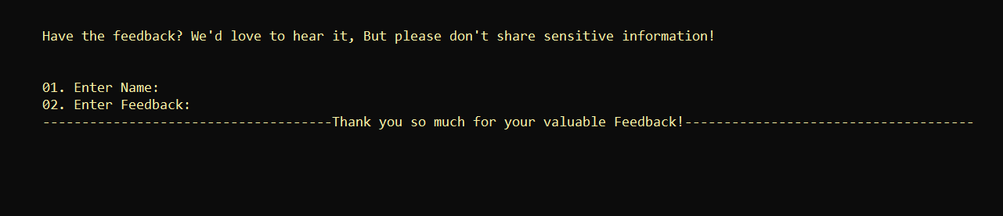
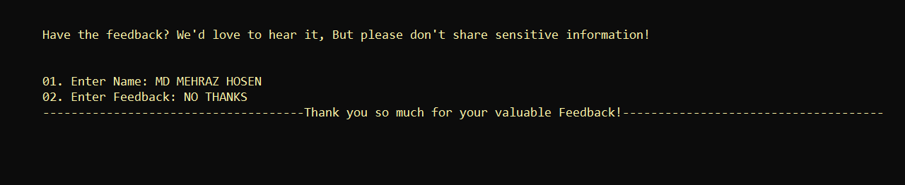

Some important note: In this project, we can easily switch from any module / sub-module to any other module / sub-module.

Conclusion
Nothing is perfect in this world. So, we are also no exception. Although, we have tried our best to present the information effectively, yet, there can be further enhanced in the Application. We have taken care of all the critical aspects, which need to take care of during the development of the Project. Like the things this project also has some limitations and can further be enhanced by someone, because there are certain drawbacks that do not permit the system to be 100% accurate.

Future Enhancement
The project didn't cover all the requirements. Further requirements and improvements can easily be done since the coding is mainly structured or modular in nature. Improvements can be appended by changing the existing modules. We think that not a single project is ever considered as complete forever because our mind is always thinking new and our necessities also are growing. Our application Also, if you see at the first glance that you find it to be complete but we want to make it still mature and fully automatic. As the system is flexible you can generate more reports and screen as and when required.

The End

